**Sample User Guide excerpt**

**1.0 What is OASIS?**

**OASIS** is an employee records management cum communication system. This desktop application enables office managers to file and recall employee data; manage employee work schedule and leave application; and email employees directly without opening an email application. This application uses a command line interface; this means that you operate the application by typing commands into a Command Box.

This is what **OASIS** looks like:

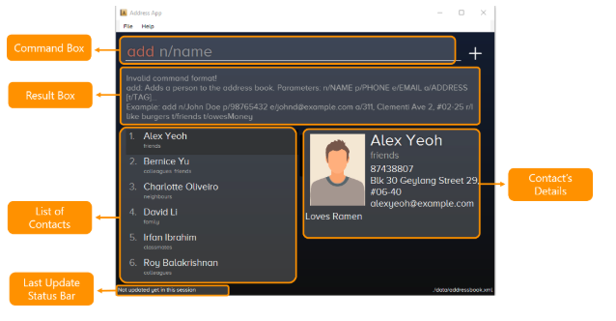

*Figure 1. The graphical user interface for* ***OASIS****.*

**2.0 About this document**

This document shows you two basic features in **OASIS**, the undo and redo commands.

Note the following symbols and formatting used in this document:

|  |  |
| --- | --- |
|  | This symbol indicates important information. |
| undo | A grey highlight (called a mark-up) indicates that this is a command that can be typed into the command line and executed by the application. |

**3.0 Basic commands**

This section contains basic commands for **OASIS**.

**Undoing a previous command:**undo

This command restores **OASIS** to the state before the previous command was executed.

Example:

Let’s say that you have been entering contact information into **OASIS**, and you have accidentally deleted a contact (John Doe) from your list!

Instead of re-entering John Doe’s contact information all over again, you can easily restore all of John Doe’s details by undo -ing the delete command you have just entered.

To undo:

1. Type undo into the command box, and press Enter to execute it.

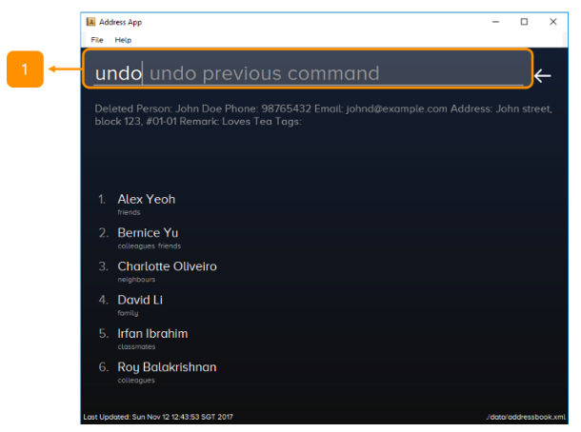

1. The result box will display the message “Undo success!”

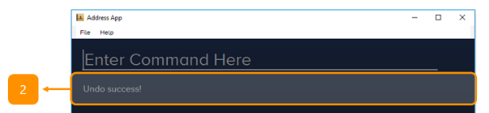

1. And you can check John Doe’s contact information is visible in the list again.

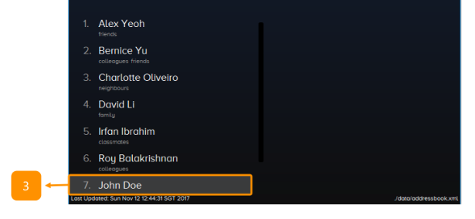

|  |  |
| --- | --- |
|  | **The undo feature applies to only undoable commands.**  Undoable commands are commands that modify **OASIS**’s content, such as add, delete, edit and clear. |

|  |  |
| --- | --- |
|  | **The undo command only reverses undoable commands.**  Let’s say you have executed a select command to select and view the information for a contact in your list. If you were to now execute the undo command, this command would fail because select is not an undoable command. |
|  | **The undo command reverses previous commands in reverse chronological order.**  Let’s say you have executed   1. the delete command, 2. followed by the clear command.   Executing undo now will first reverse the clear command.  Executing undo again will now reverse the delete command. |

**Redoing an undone command:**redo

This command reverses the most recent undo command.

Example:

Let’s say you have executed the delete command to delete John Doe from your list.

You may undo this action and restore John Doe’s information by executing the undo command. (See **Undoing a previous command.**)

Then, if you decide that you want the contact to remain deleted after all, you may very quickly and easily execute the redo command to reverse the undo command that you had just executed.

To redo:

1. Type redo into the command box, and press Enter to execute it.

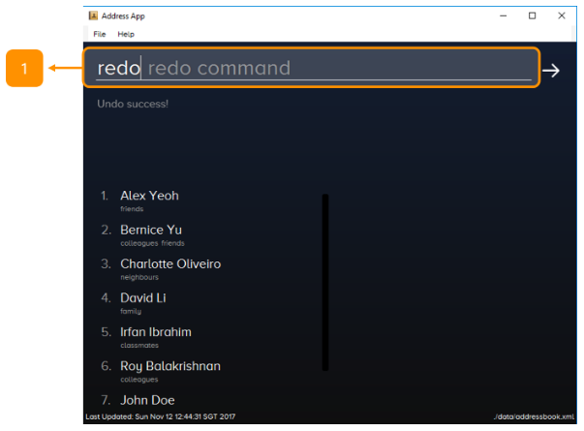

1. The result box will display the message “Redo success!”

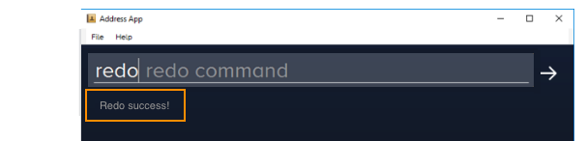

1. And John Doe is again gone from the list.



|  |  |
| --- | --- |
|  | **The redo command reverses only the undo command.**  Let’s say you have executed the delete command to delete a contact in your list.  Then you execute the redo command. This command will fail because no undo command was entered before this. |
|  | **The redo command reverses previous undo commands in reverse chronological order.**  Let’s say that you have executed the delete command, followed by the clear command.   * Executing undo now will reverse the clear command. Executing undo again will then reverse the delete command as well. * Following this, executing redo will now reverse the last undo command and reapply the delete command. Executing redo again will reverse the second last undo command and reapply the clear command. |